German University in Cairo
Computer Vision
Assignment 4
Frederic-Gerald Morcos 4-1805

Introduction:

This assignment is written in C++ and OpenCV for image manipulation. It can be imported into an Eclipse CDT or Anjuta project and run normally or can be built from the command line by running "make" in the same directory of the project. The binary produced takes three arguments (the questions) which have to be set in the Eclipse CDT or Anjuta prior to running or passed to the binary as an argument "./cv4 [q1 | q2 | q4]".

PS: Code is fully commented.

Question 1:

In this problem we need to match two points in two images to each other by checking the similarity of their neighborhoods by using SSDs and SADs. The most minimal difference is considered a matching pixel and its position can be detected, thus, how far and in which direction it has moved can be deduced. Pixel (36, 36) in image 1 (guc1_1058) was chosen due do its noisy neighborhood which will give a better match. The candidates for matching to this pixel are the 11x11 area around it in image 2 (guc2_1059) - 5 pixels north, 5 west, 5 south, 5 east + 1 at the center which is also (36, 36) in image 2. This area is scanned with a 5x5 kernel of neighborhood to detect each SSD/SAD (note that both use the same algorithm, a pointer to a function implementing either squared() or absolute() is passed to the sxd() function to use it). The minimal SXD is calculated on the fly and its position is stored. When the algorithm is done, the position detected from image 2 is compared with the one in image 1 and the direction is detected. Output of the problem is shown in the figure below.

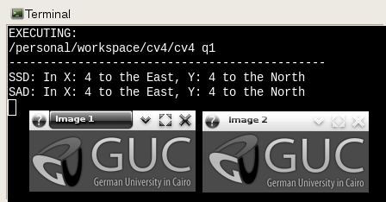

Question 2:

The images are loaded into windows along with matching points from the file "points.txt" and callbacks are set to when a click happens on an image, the point's epipolar line is shown on the other image (matching the same point in the other image). The lines intersect at a certain point on the image depending on the accuracy and placements of the selected matching points to generate the fundamental matrix. Two examples are shown in the images below.

Usage: ./cv4 q2

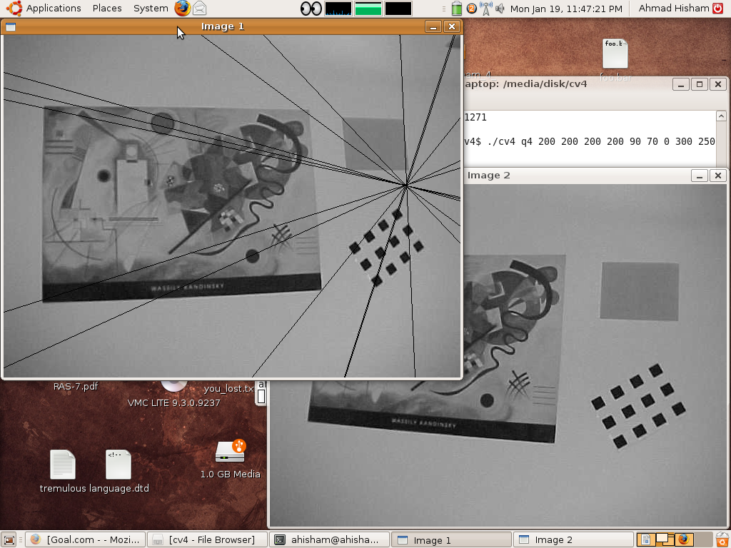

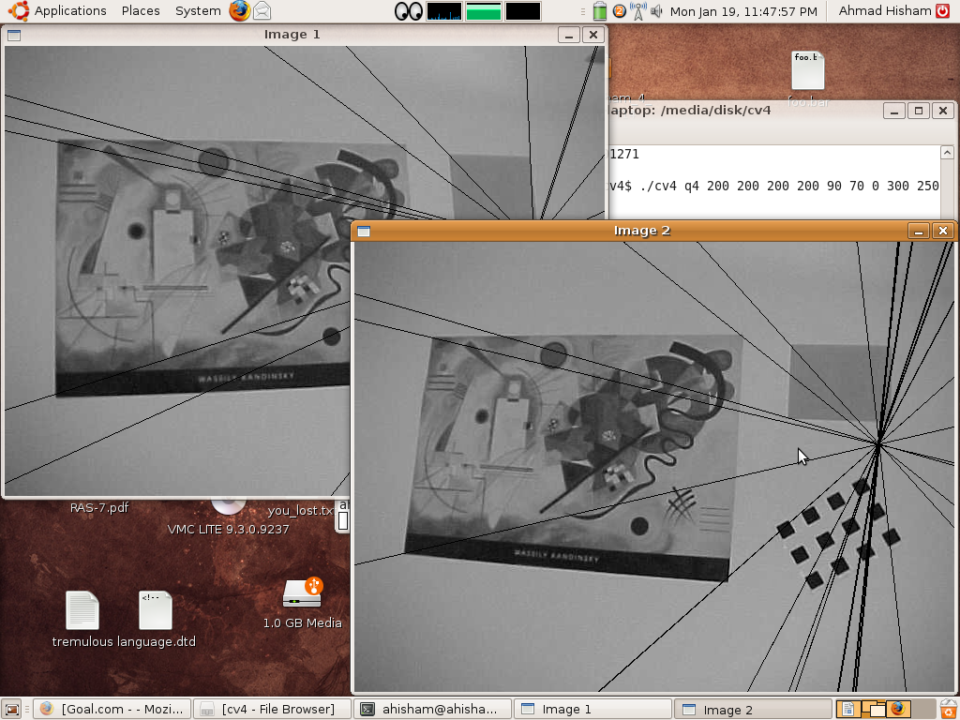

Question 4:

A 2D plane image is input (taken from a 3D plane) and the 3D plane is output depending on the camera's position and calibration. Matrices to achieve homography transformation are calculated and source pixels are then inserted into destination pixels (in the destination image). Three examples are shown below.

Usage: ./cv4 q4 res_width res_height alpha_u alpha_v pan tilt swing cam_x cam_y cam_z

